Activity One: Read chapter two to find the answer to these questions.

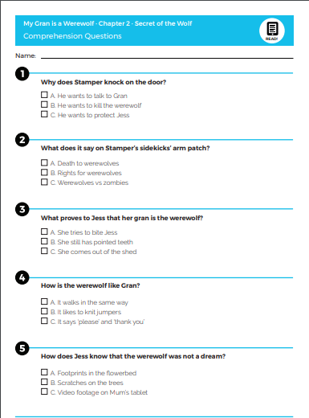

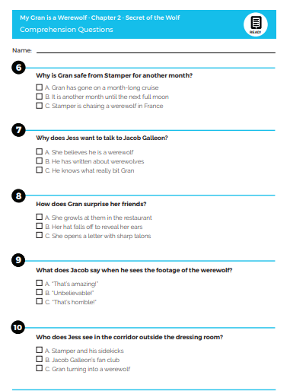

Activity Two : Direct speech. Look at chapter 2 to find out who said what.

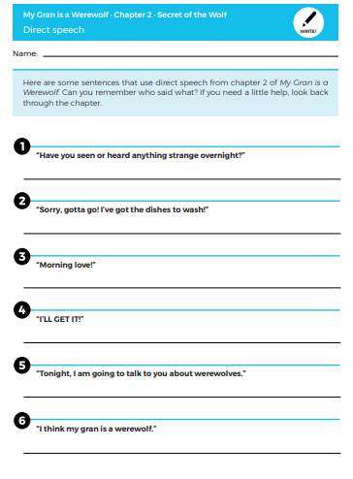

Activity Three : Direct speech. Write the sentences in your books adding in the inverted commas if you need to. Remember to use your best handwriting.

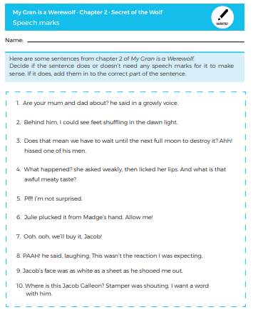



Activity Four: Draw you as a werewolf and write three phrases that you would say.

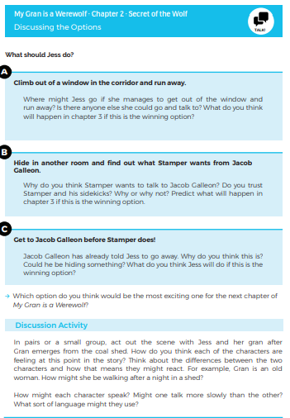

Activity Five: Have a go at a bit of acting with an adult or brother and sister.

Additional Activities

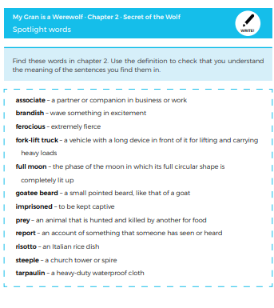

Write a sentence to include each of the above words.

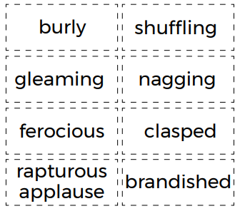

Look up the meanings of these words if you don’t know them. Write a sentence for each word.