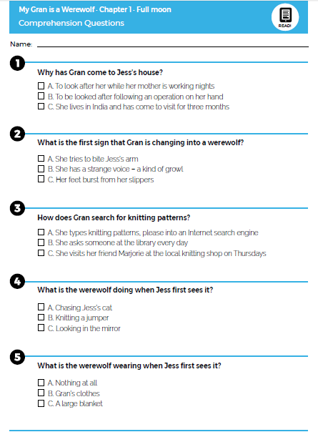
Activity One: Read chapter one to find the answer to these questions.

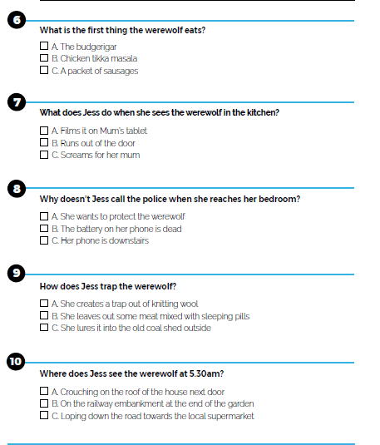
Activity Two : Find the meaning of each of these keywords from chapter one and write a sentence to include each one.

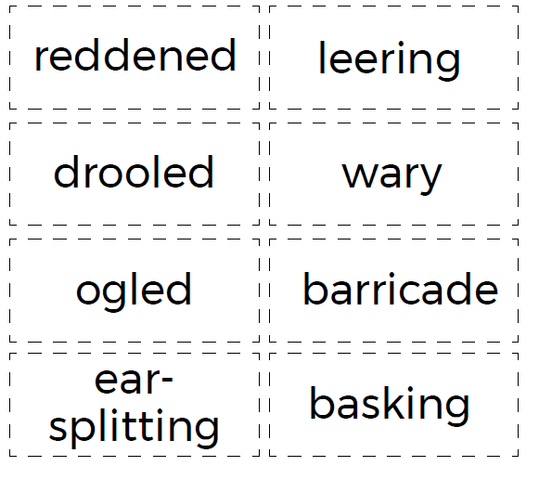

Activity Three : Vocabulary meanings- when you have found the words on chapter one, write a sentence to include each word.

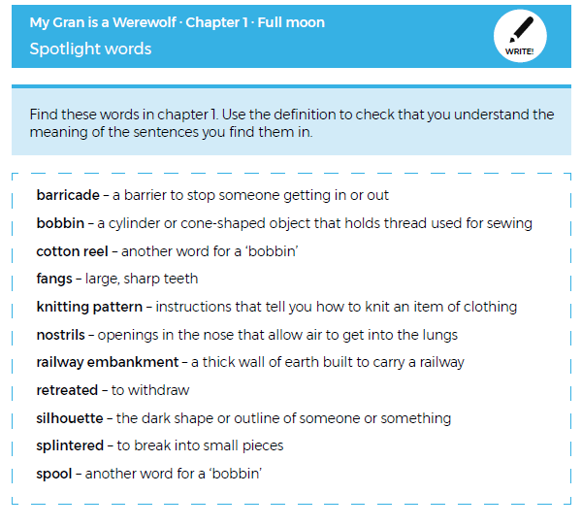

Activity Four: Expanded noun phrases. A noun phrase has to include a noun ( a person, place or thing) e.g. the moon. Try to include expanded noun phrase using adjectives. ( a describing word)e.g. The cold, white moon… Challenge yourself to extending your sentences even further e.g. The cold, white moon slowly rose above the city.

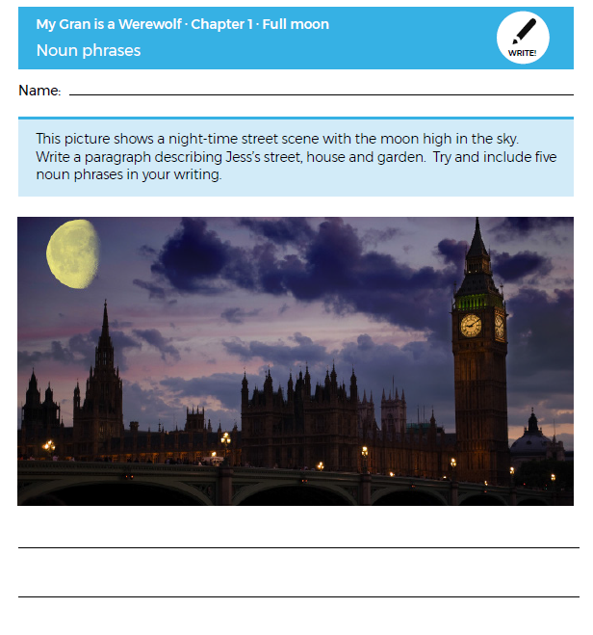
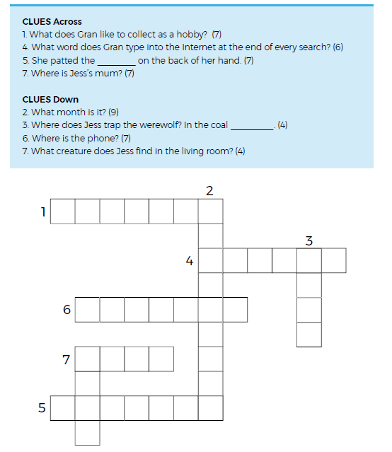
Activity Five: Crossword Use chapter one to help you answer the crossword clues.
Additional Activities
- After reading Chapter One, have a think about these questions. You can either discuss them with an adult or write your thoughts in your work book.
1.What sort of person is gran?
2. What might be the significance of the cat bite?
3. How does the reader know the werewolf is gran?
4. Which fairy tale does the opening chapter remind you of?
5. What does the werewolf look like?
6. How does Jess react? What would you do in that situation?

- Draw a picture of the werewolf using clues from the text. You could also add sentences or phrases to describe it.

- Think about what might happen in chapter 2. How would you have voted? Which person would be at the door?
See below for the options.

