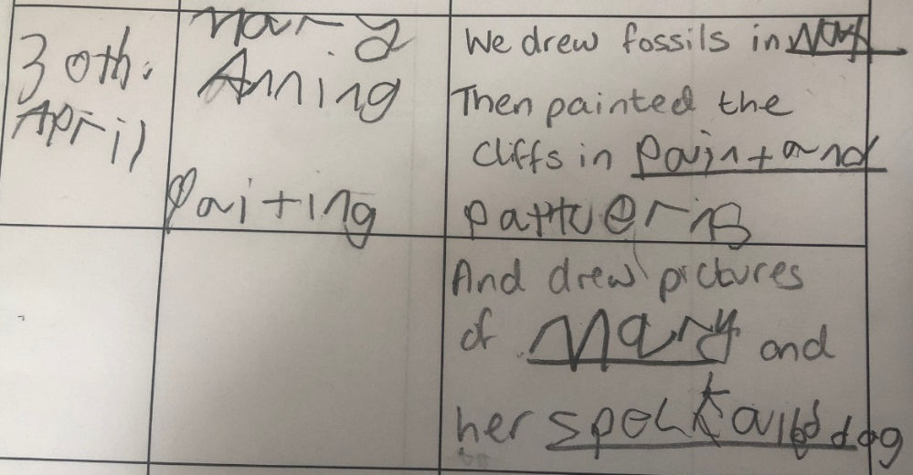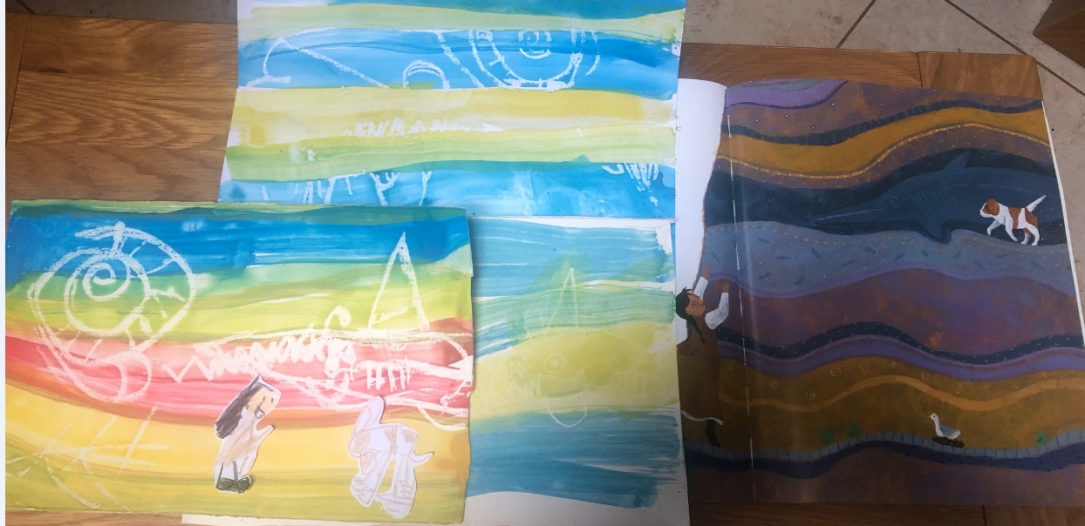

Finn drew “fossils” out of a wax candle, then we “discovered” them like Mary Anning and her speckled dog when we painted the cliff wall over the top.