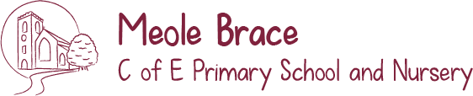
Let Your Light Shine!

Reading and Phonics in Early Years
We teach children to read in a guided reading group twice each week or individually with an adult in school. We use the DfE approved Bug Club Phonics programme to help teach children to read and spell with phonics. Our guided reading books and home reading books are from the Bug Club programme.

Children can be helped to read at home at home by sharing their school reading book for 5 minutes, 5 times a week. A regular, short, ‘little and often’ session will work best. Look inside the front cover of the books for tips on how to help your child and questions to ask. Your child’s school reading books are very important to develop early reading skills as they will contain the sounds we have been learning in school and your child will be able to learn to ‘sound talk’ and decode these words. The books will also contain the ‘irregular tricky’ words we have been working on in school that cannot be ‘sound talked’ but must be learnt by sight.
Make time for looking at picture story books you have at home and books from the library. A bedtime story is the perfect time to do this.

We aim to develop the following skills in reading by the end of EYFS in Reception:
• I am developing an interest in reading and enjoy looking at books.
• I know how to turn a page and to read from left to right.
• I can read and understand simple sentences.
• I can use phonic knowledge to decode regular words and read them aloud accurately.
• I can read all phase 2 tricky words on sight and some phase 3 tricky words.
• I can talk to others about what I have read.
• I am Key Stage One ready.

