Early Years Foundation Stage (EYFS)

The EYFS gives children secure foundations for later learning.

What does it involve?
There are 7 areas of learning in the EYFS. These consist of 3 prime areas and 4 specific areas:

- Personal, Social and Emotional Development (Prime Area)
The development of confidence and independence, making relationships and managing feelings and behaviour,

- Communication and Language (Prime Area)
Developing skills in speaking, understanding and listening.

- Physical Development (Prime Area)
Developing control and coordination of the body in large and small movements such as climbing, running and using tools such as pencils and scissors, as well as the development of self-care skills.

- Literacy (Specific Area)
Developing early reading and writing skills.

- Maths (Specific Area)
Developing early counting and understanding of number, alongside skills in shape, space and measures.

- Understanding the World (Specific Area)
Investigating and beginning to understand the things, places and people around them.

- Expressive Arts and Design (Specific Area)
Using imagination through a variety of media and materials.

How do we Learn?

In our Reception classes at Meole Brace, we learn by becoming Explorers, Creators and Investigators.

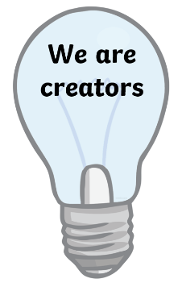

As a creator, children can use instruments to make music. They build and craft using construction resources and art materials. They can retell and make up stories using props, small world figures or through writing.
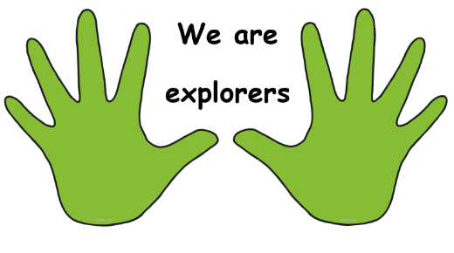

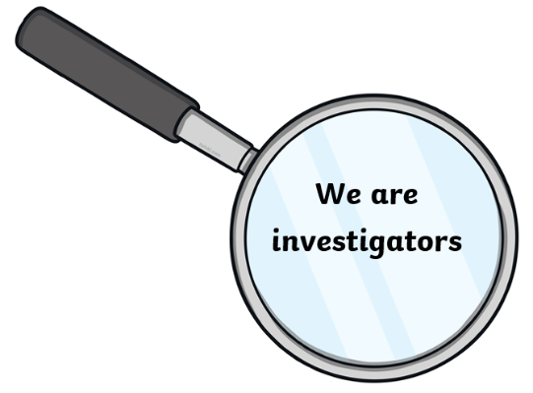
As an explorer, children experience and play in different areas, with resources and activities. This type of activity allows children to build familiarity.

As an investigator, children can find the answer to a question. They can solve problems, make links and think.

